**Class**: F.Y.MCA **Semester**: II

**Course**: Process Automation

**Name:** Vivek Tiwari

**UID:** 2023510059

**Expt. Title: Web Scraping Problem Statement: Web Scraping**

**Actions used:**

**Browser: Open**

Opens the specified web page in the browser.

**Recorder: Capture**

Record interactions with UI elements such as click, read, and write.

**Simulate keystrokes**

Inserts keystrokes into a selected window.

**Number: Assign**

Assigns user specified number to number variable

**Number: To string**

Converts a user specified number to a string

**Excel advanced: Open**

Opens a Microsoft Excel spreadsheet or a CSV file. You can open the spreadsheet in read- only or read-write mode, with a password, and so on.

**Excel advanced: Go to cell**

Moves the cursor to a specific cell in a Microsoft Excel spreadsheet or a CSV file.

**Excel advanced: Set cell**

Sets a value in the Active cell or Specific cell in a Microsoft Excel spreadsheet or a CSV file. You can also use this action to set a formula

**Loop**

Runs a sequence of actions for a specific number of times or until a condition is met.

**Number: Increment**

Increments a number by specified value

**Number: To string**

Converts a user specified number to a string

  Step 1: use browser open to open the site from which you want to fetch the data

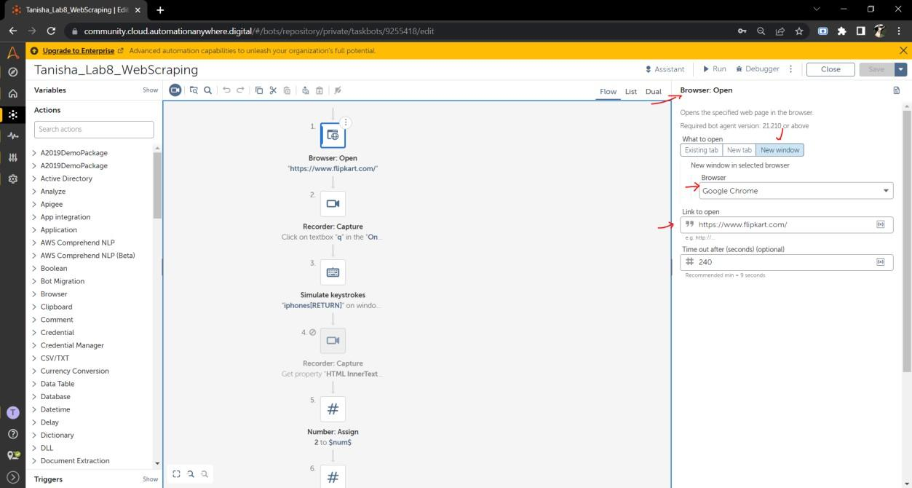

Step 2: use recorder capture to capture the data of the search bar where we will type the product name

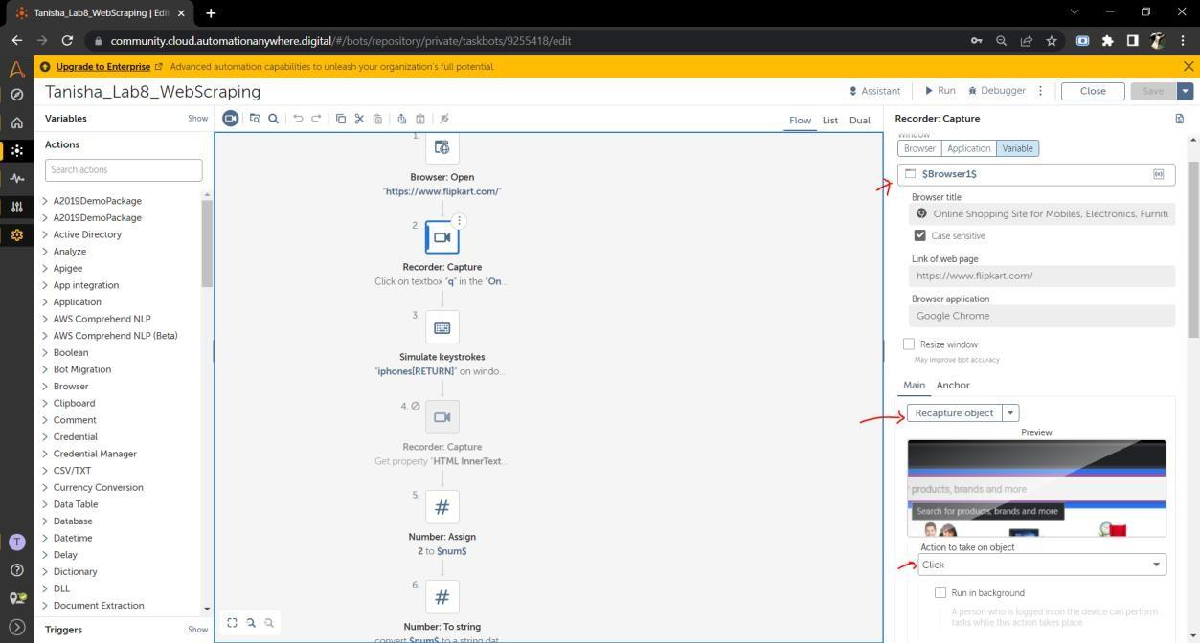

Step 3:use simulate key strokes to search for iphones and return

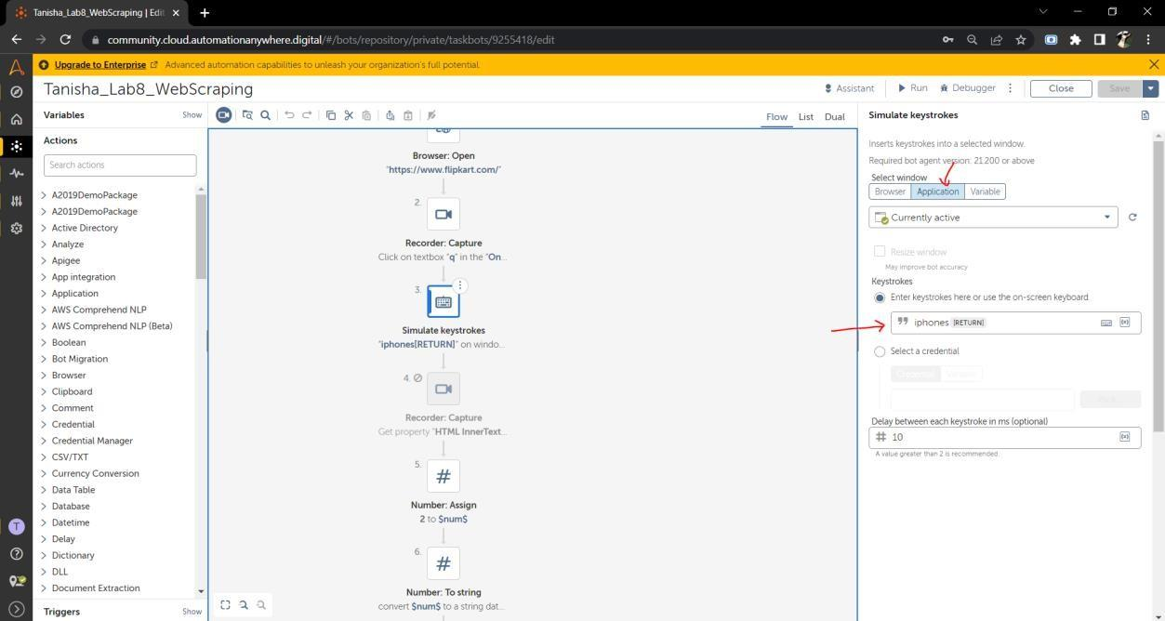

Step 4: Use number assign and set to 2 because the first product is sponsored > assign it to destination variable num

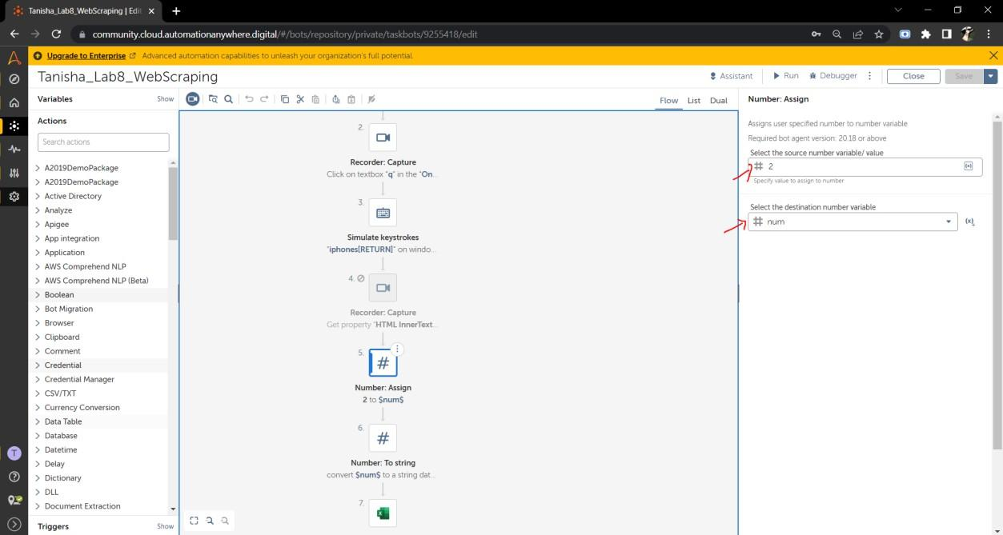

Step 5: use num string because automation anywhere needs string values to work on > convert the number from num to string

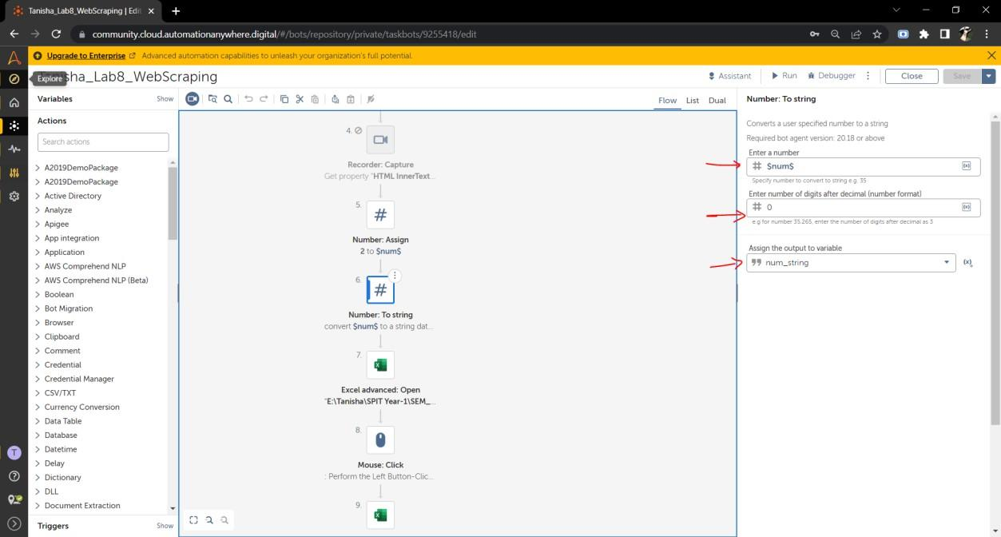

Step 6: Use excel open and specify the file path of the file

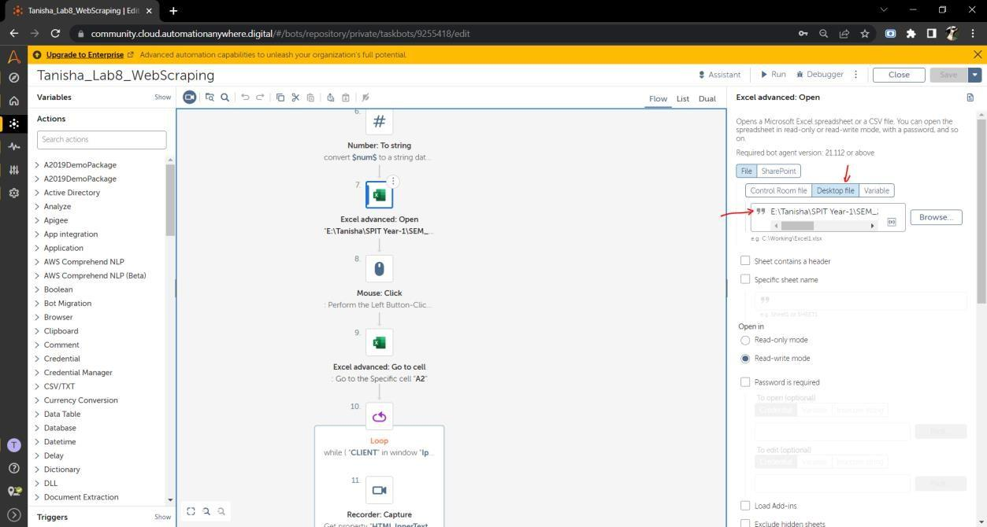

Step 7: use mouse click to close the Microsoft activation needed pop up

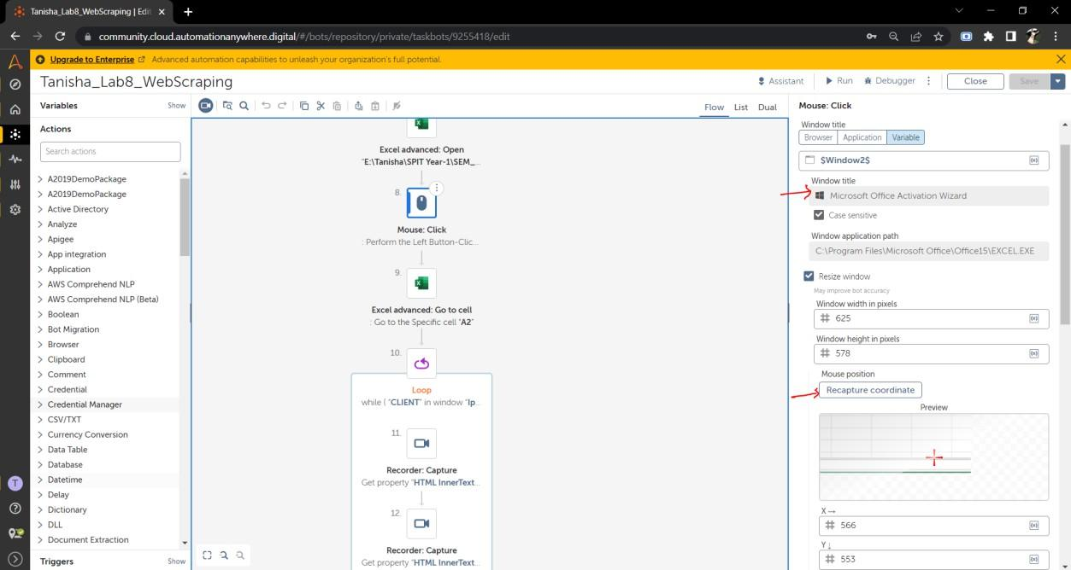

Step 8: in the excel sheet go to cell A2 where we will start writing the data

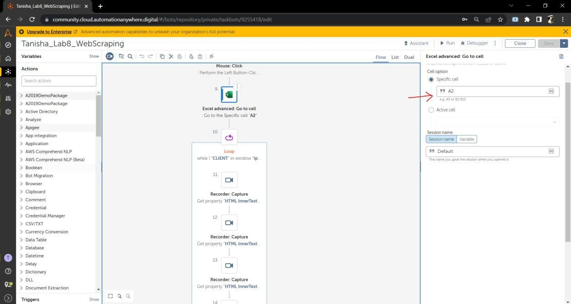

Step 9: use a loop > and select while condition > we will run this loop till we see if the recorder captured object i.w the title exists of each of the iphone > set the DOM Xpath of the product > right click on flipkart side > inspect > select desktop and arrow and hover on the title > right click and copy xpath > if we do that for 3-4 products we will see a pattern > increasing numbers

* select the xpath of unsponsored product and set it as num_string to iterate through the ids > add an AND and another condition and set number condition > set the num value to less than 8 so we can only copy items from 2 to 8 that is 5 items

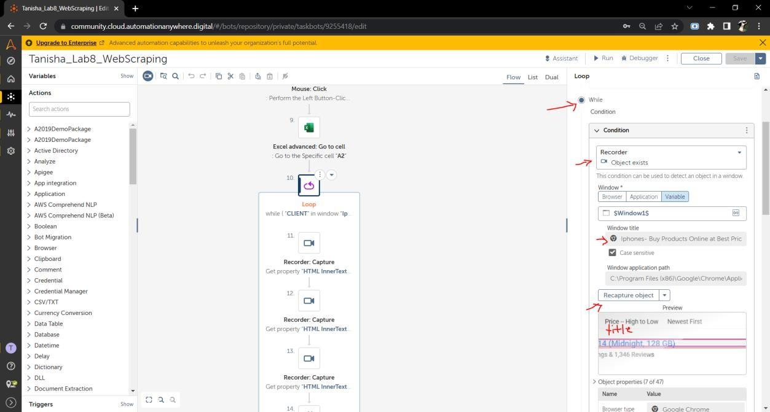

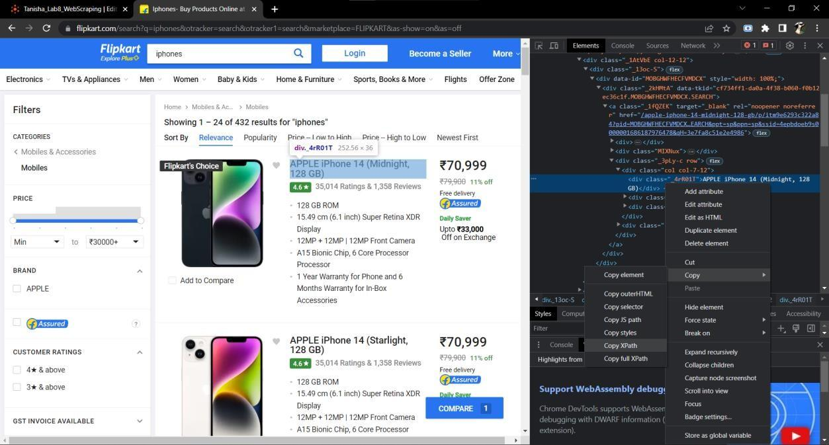

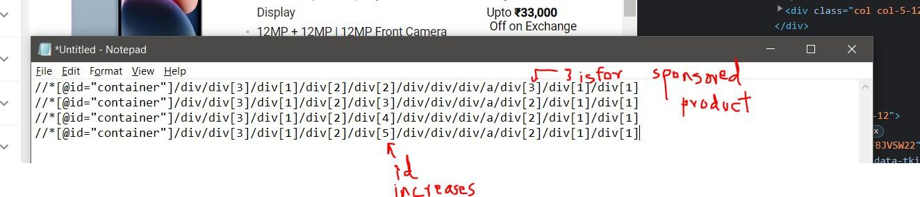

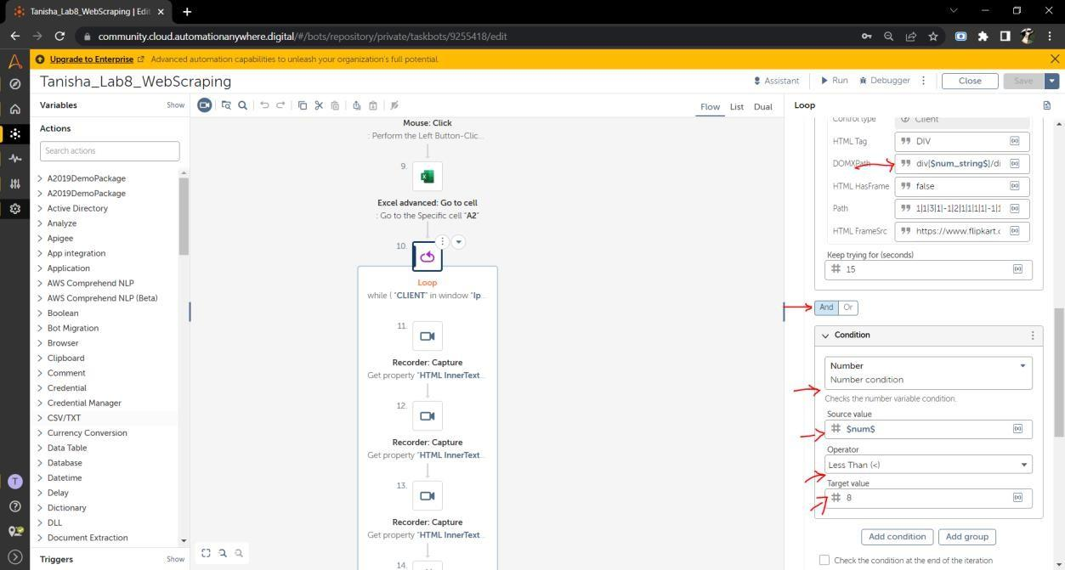

Step 10: take recorder capture > set the browser > capture the title object because we want to fetch that first > select action to take as get property > set property name as HTML InnerText

* set the DOMXpath by inspecting and capturing of the sponsored item and paste it > set the output to a string variable (create it) > this will fetch the name using x path and store it in the string variable

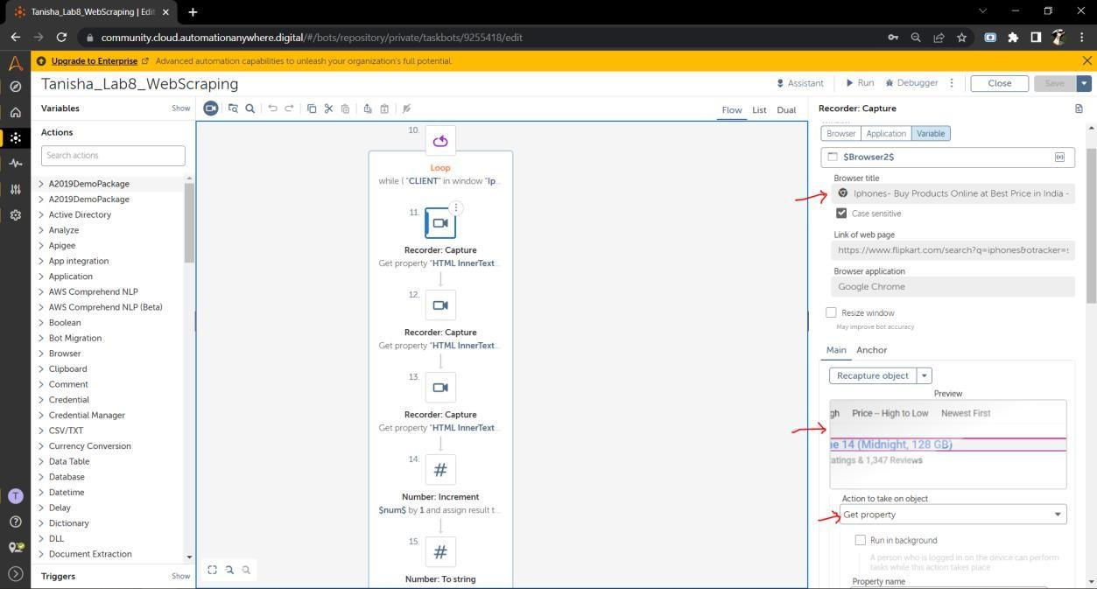

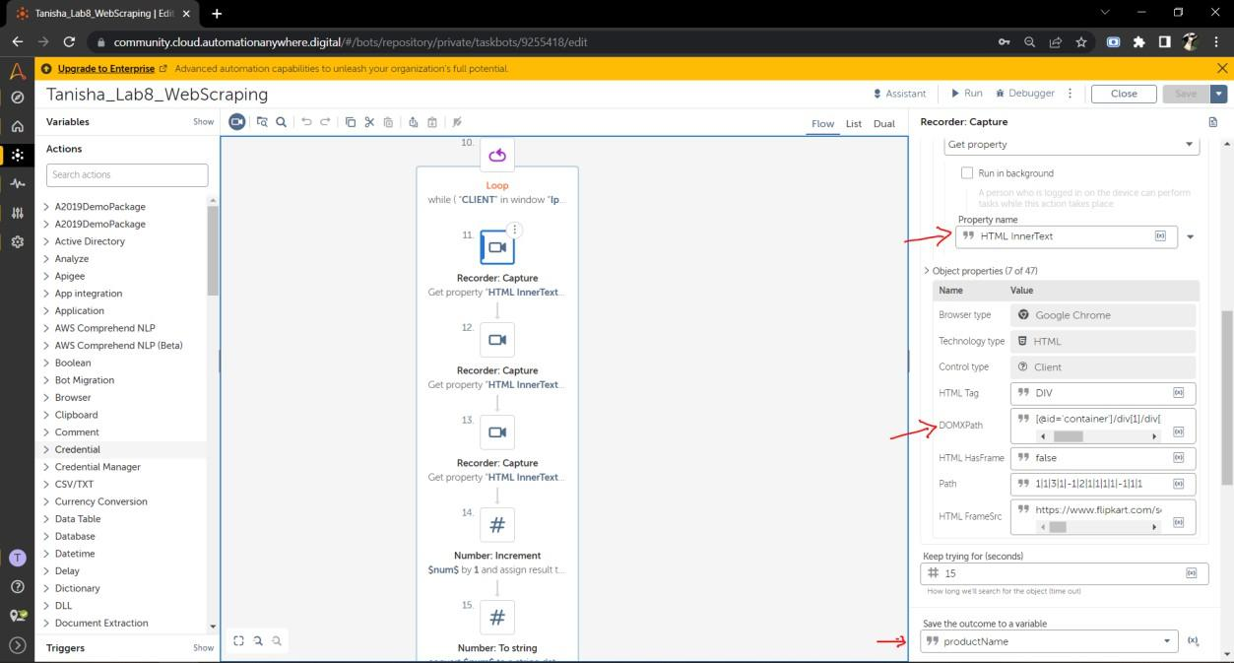

Step 11: capture price and again set its xpath using inspect and copying sponsored item’s xpath > store the output in a string variable (create it)

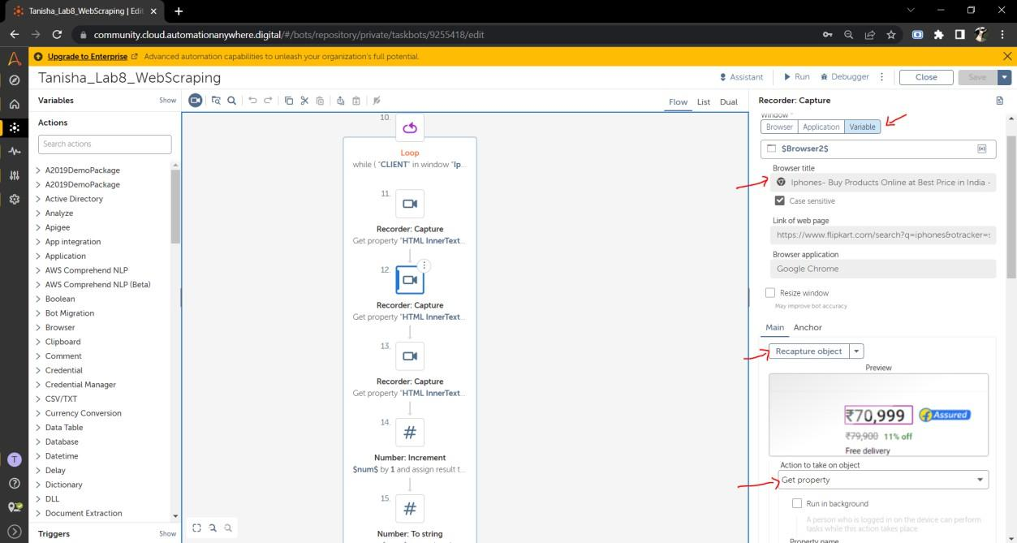

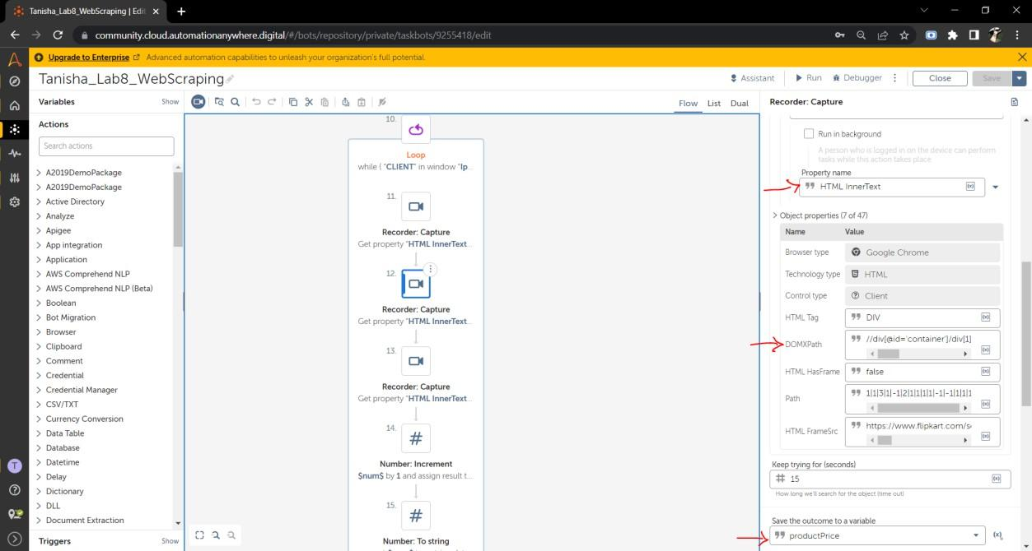

Step 12: repeat the same step as the previous one but for product description

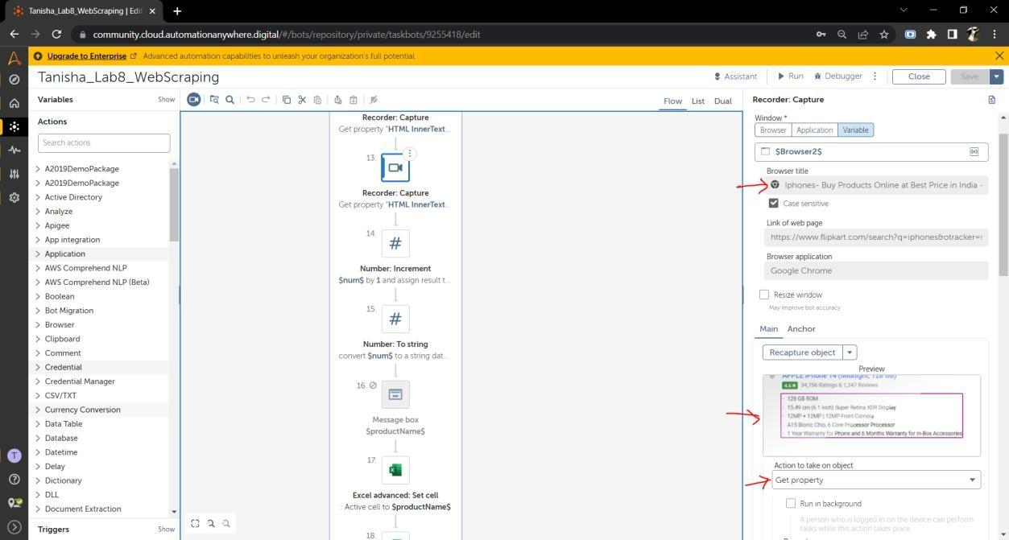

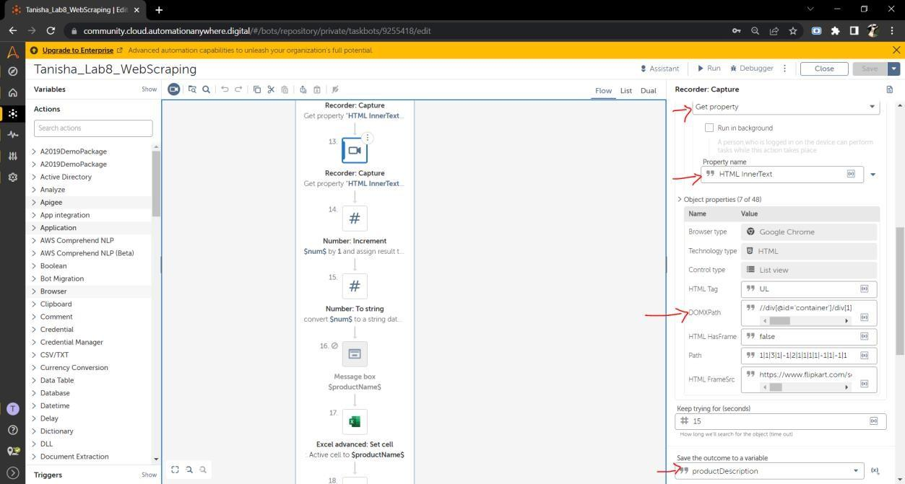

Step 13: use number increment to increment through the loop

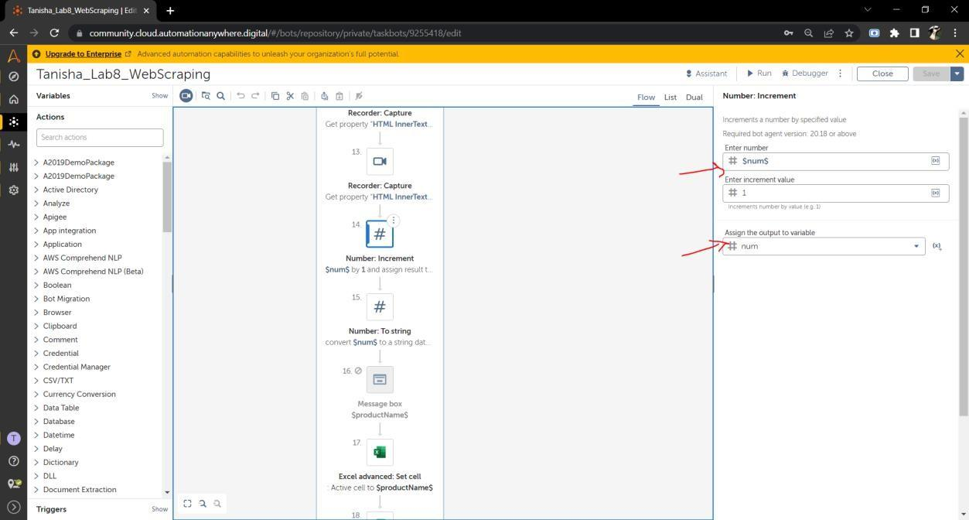

Step 14: use num to string to convert number to string because automation anywhere cannot read number values

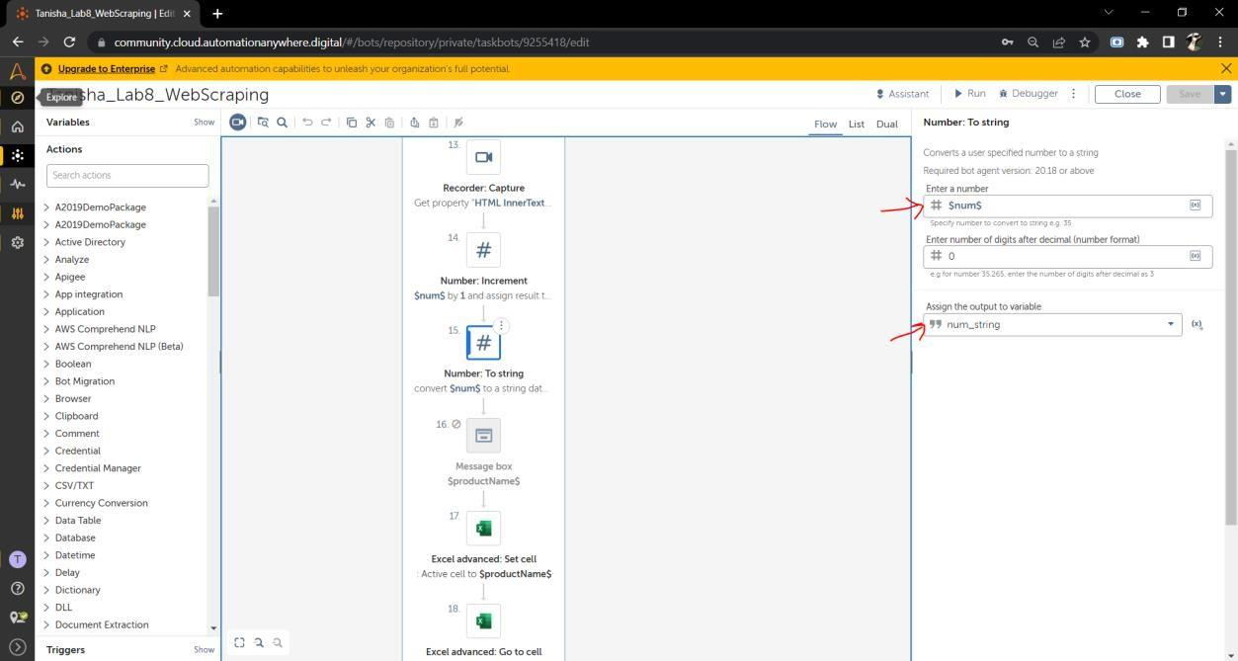

Step 15: Since we are on cell A2 as specified in step 8 (action 9) > on the active cell print productName

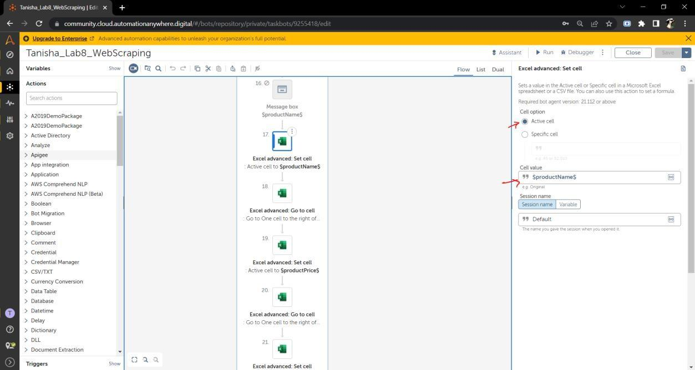

Step 16: use go to cell > set active cell > on cell to the right to move to next cell so that we can print the product

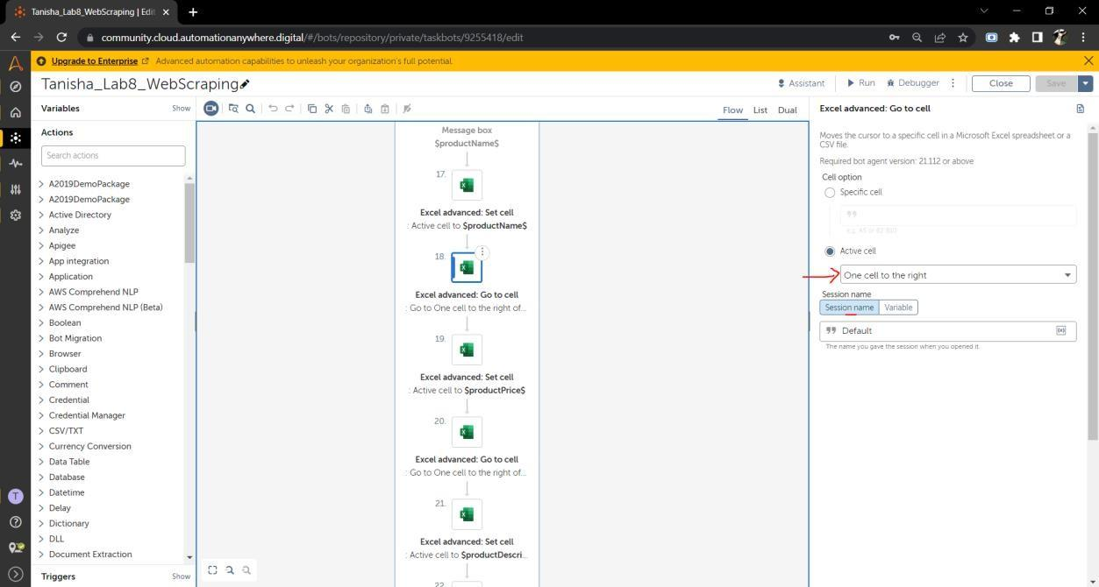

Step 17: set cell product price and use another go to cell > one cell to the right

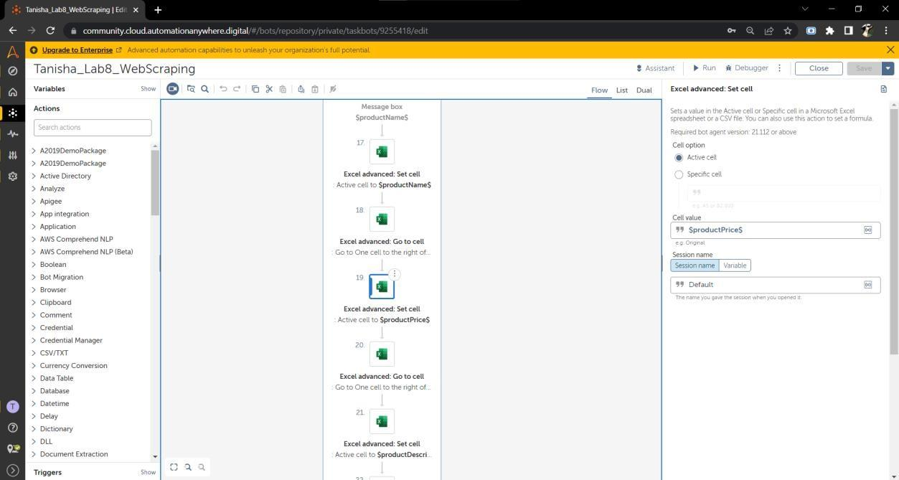

Step 18: set cell > print product description

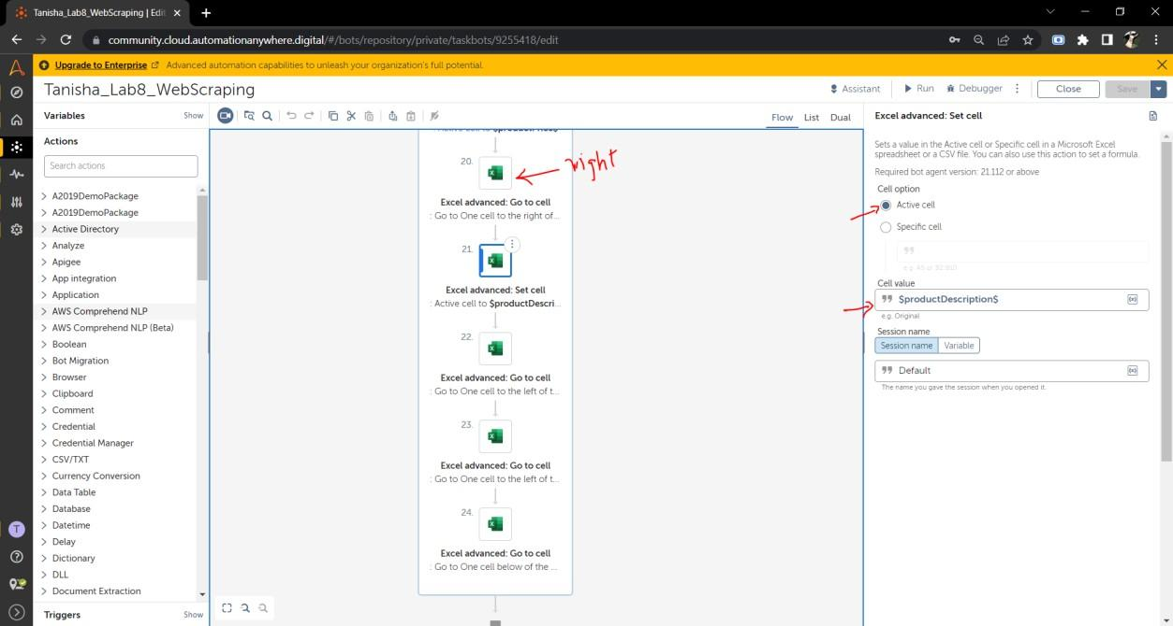

Step 19: use 3 go to cell and go to left - left – below to print the details of the next product

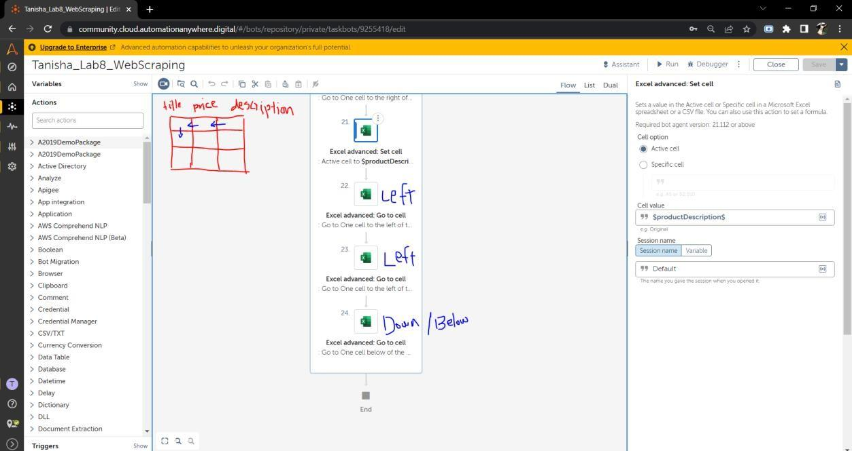

**OUTPUT:**

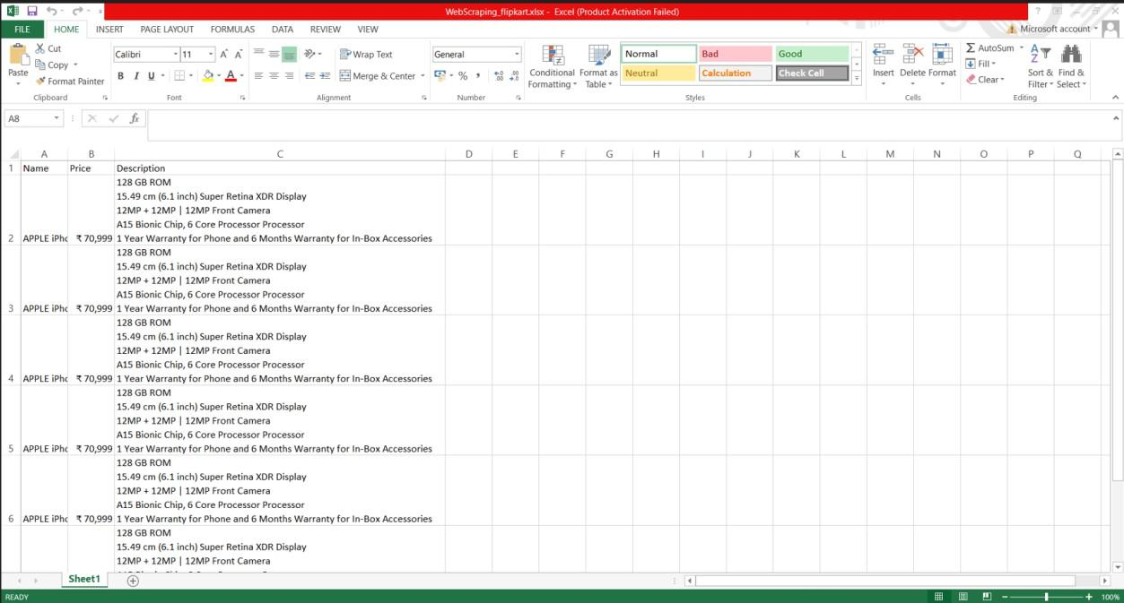

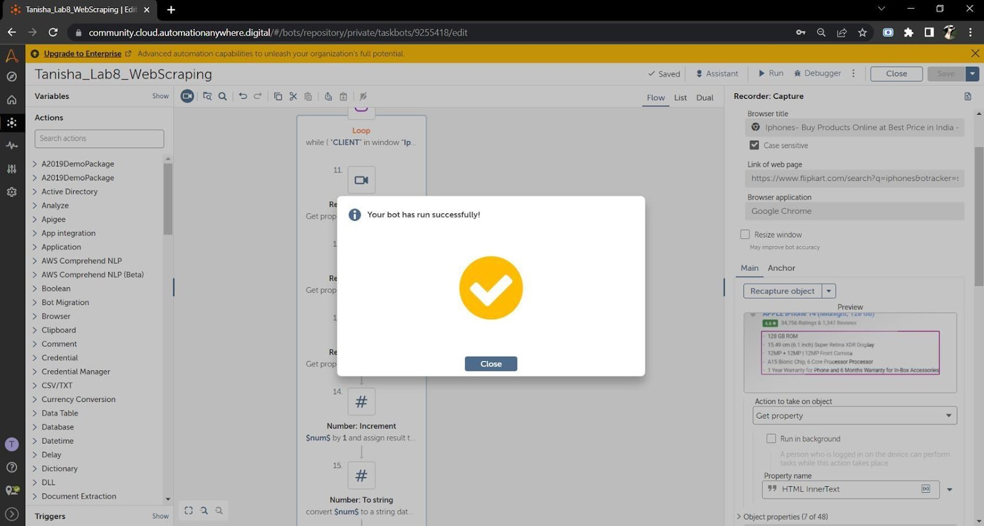

**CONCLUSION:**

We have learnt how to perform web scraping and extract data from the website and store it in a excel file. We have used the Xpath of the document object model of HTML to fetch and iterate through the data. We have used actions like go to cell, excel open, set cell, num increment, num to string, num assign, recorder capture, loop, browser open, simulate keystrokes and mouse click. Successful extraction of the data is done.